4 Observability Layers Every AI Developer Needs for Production AI Agents

https://pub.towardsai.net/4-observability-layers-every-developer-needs-for-production-ai-agents-a-complete-guide-24db9cbcb83c

We build Enterprise AI. We teach what we learn. Join 100K+ AI practitioners on Towards AI Academy. Free: 6-day Agentic AI Engineering Email Guide: https://email-course.towardsai.net/
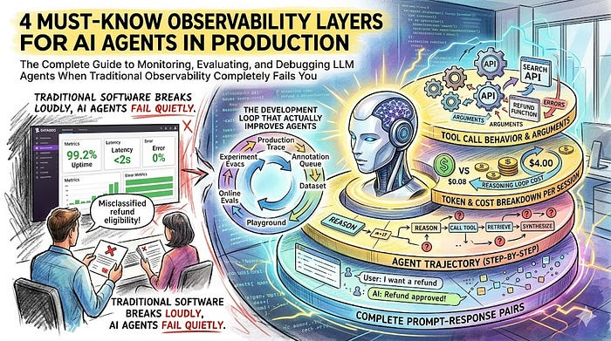

The complete guide to monitoring, evaluating, and debugging LLM agents when traditional observability completely fails you
It was a Tuesday when one of our customers filed a support ticket.
The AI agent handling order queries had been live for a month. Metrics looked clean: 99.2% uptime, average latency under 2 seconds, error rate near zero. Everything dashboards are supposed to tell you.
Except the agent had been misclassifying refund eligibility for twelve days. Not crashing. Not erroring. Answering confidently and incorrectly, at scale, to paying customers. Our Datadog was silent the entire time.
The bug lived in the quality of the output, not the system.
That is the trap every team building AI agents falls into. You monitor your servers like it is 2015 while your agent hallucinates, loops, misroutes tool calls, and degrades quietly. You find out from a customer, not your own systems.
This article covers what to actually observe, how to evaluate at scale without going broke, and the specific techniques that work in real production deployments.
Trust me, this is a key skill for building production ready AI Agents.

Why Your Existing Monitoring Completely Misses the Point
Press enter or click to view image in full size
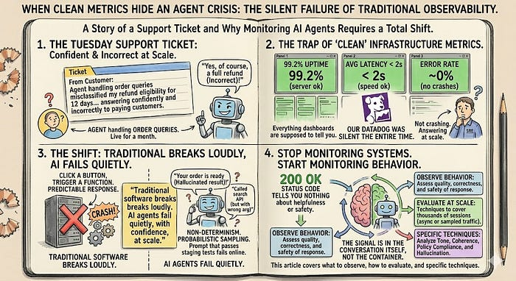
Photo by author
Traditional monitoring was designed for one type of system:
Deterministic.
Click a button, trigger a function, get a predictable response. You enumerate failure modes, write tests for them, set alerts.
AI agents are different on two dimensions that completely break that model.
Infinite input space. A customer returns an item. In a traditional app, they click a fixed flow. In an agent, they might say:
- “I want to return my order”
- “Can you help me get my money back for the shoes I bought last week?”
- “order #12345 refund please”
Same intent. Completely different phrasing. You cannot write a test that covers all 10,000 ways a human expresses “I want a refund.” You discover them in production.
Non-determinism. LLMs use probabilistic sampling. The same prompt produces different outputs across runs. A prompt that passes every staging test will fail on edge cases you never saw. A tool-calling pattern that worked in evaluation will occasionally misfire in production on subtly different queries.
Here is the shift: stop monitoring systems. Start monitoring behavior.
A status code of 200 OK in 1.2 seconds tells you nothing about whether the agent gave a correct, helpful, safe answer. The signal you need is in the conversation itself, not the container it rode in.
“Traditional software breaks loudly. AI agents fail quietly, with confidence, at scale.”
Press enter or click to view image in full size
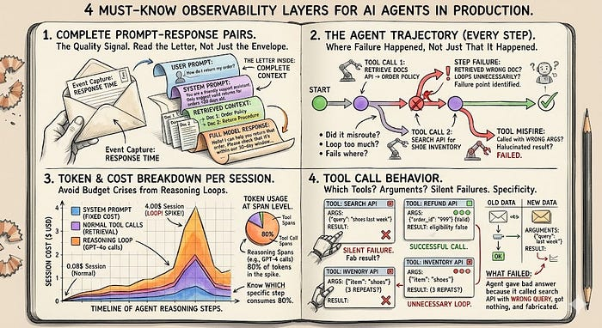
Photo by author

The Four Things You Actually Need to Capture
Most teams capture one: response time. Here is what matters.

1. Complete prompt-response pairs
Not that a request happened. The full text of what the user sent, the system prompt, any retrieved context, and the full model response.
This is where the quality signal lives. Without it, you are reading the envelope while the letter inside is wrong.

2. The agent trajectory (every step, not just the final answer)
Agents reason, call tools, retrieve context, reason again, call more tools, synthesize. Each step is a failure point.
Monitoring only the final output tells you that something went wrong. The trajectory tells you where.
“Did it retrieve the wrong document? Call the wrong tool? Loop unnecessarily? You can’t answer these without step-level visibility.”

3. Token and cost breakdown per session
A single agent stuck in a reasoning loop can make 50+ LLM calls before timing out. At GPT-4o pricing, that is a $4 session instead of a $0.08 one. Multiplied across thousands of users, those anomalies become budget crises by month-end.
Track cost at the span level. Know which specific step is consuming 80% of your tokens.

4. Tool call behavior
Which tools did the agent call? With what arguments? Did it call the same tool three times unnecessarily? Did it fail silently and fabricate a result?
Tool call monitoring is the difference between “the agent gave a bad answer” and “the agent gave a bad answer because it called the search API with the wrong query, got nothing back, and hallucinated instead of escalating.”
Specificity is everything here.

The Evaluation Problem No One Talks About Honestly
Here is the uncomfortable truth.
Human reviewers are the gold standard for judging output quality. Is this response helpful? Did the agent understand intent? Was the information accurate? Humans answer these correctly.
But at 1,000 requests per day, full human review requires 10 to 20 hours of focused time. Daily.
That does not scale. Full stop.

Two approaches close the gap:
Press enter or click to view image in full size
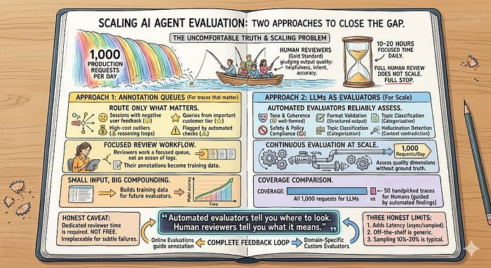
Photo by author

Approach 1: Annotation Queues (For the Traces That Actually Matter)
Instead of asking reviewers to hunt through raw production logs, an annotation queue surfaces specific traces for review with a predefined rubric.
Route only what matters:
- Sessions that received negative user feedback
- High-cost outliers (potential reasoning loops)
- Queries from your most important customer tier
- Anything flagged by automated checks
Reviewers work a focused queue, not an ocean of logs. Their annotations become training data for the next evaluator you build. It is a small input that compounds over time.
Honest caveat: annotation queues require dedicated reviewer time. They are not free. But focused on the right traces, they are irreplaceable for catching subtle failures that automated systems miss.

Approach 2: LLMs as Evaluators (For Scale)
LLM-as-judge is the technique that makes continuous evaluation possible. You configure automated evaluators that run on production traffic, assessing quality dimensions that do not need a ground truth answer.
What automated evaluators reliably assess:
- Tone and coherence: Is the response well-formed and on-register?
- Safety and policy compliance: Any violations or sensitive content?
- Format validation: Does the output follow required structure?
- Topic classification: What was the user actually trying to do?
- Hallucination detection: Did the agent contradict its own retrieved context?
At 1,000 requests per day, automated evaluators cover all of them. Human reviewers cover the 50 most important ones, guided by what the evaluators surfaced.
“Automated evaluators tell you where to look. Human reviewers tell you what it means.”
Three honest limits:
- Evaluators add 1 to 3 seconds of latency. Run them async or on sampled traffic.
- Off-the-shelf evaluators measure generic quality. Custom evaluators aligned to your domain are necessary, and they require validation against human labels before you trust them.
- Sampling 10% to 20% of traffic is the cost-coverage sweet spot for most teams.

The Development Loop That Actually Improves Agents
Press enter or click to view image in full size
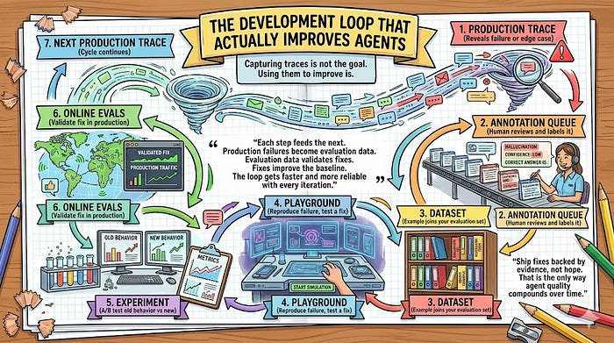
Photo by author
Capturing traces is not the goal. Using them to improve is.
Here is the loop that compounds:
Production trace → reveals failure or edge case
↓
Annotation queue → human reviews and labels it
↓
Dataset → example joins your evaluation set
↓
Playground → reproduce the failure, test a fix
↓
Experiment → A/B test old behavior vs new
↓
Online evals → validate fix in production
↓
Next production trace → cycle continues
Most teams skip from step one to step six. They fix by intuition, not evidence. They deploy hoping the fix works, discover a new edge case two weeks later, and the cycle repeats without any compounding improvement.
“Ship fixes backed by evidence, not hope. That is the only way agent quality compounds over time.”
Each step feeds the next. Production failures become evaluation data. Evaluation data validates fixes. Fixes improve the baseline. The loop gets faster and more reliable with every iteration.

Practical: Production Observability in Under 30 Minutes
Here is the minimum viable stack. I will use LangSmith as the example since it is the most widely adopted tool, but the concepts apply equally to Langfuse, AgentOps, or any structured tracing platform.

Step 1: Instrument Your Agent (2 Minutes)
import os
# Set these three environment variables and LangChain tracing is automatic.
# Every agent run, tool call, and LLM call is captured from this point forward.
os.environ["LANGCHAIN_TRACING_V2"] = "true"
os.environ["LANGCHAIN_API_KEY"] = os.getenv("LANGSMITH_API_KEY")
os.environ["LANGCHAIN_PROJECT"] = "production-support-agent"
# If you are NOT using LangChain, wrap your functions with @traceable instead:
from langsmith import traceable
@traceable(
name="classify_support_ticket",
run_type="chain" # classifies the span type in the dashboard
)
def classify_ticket(ticket_text: str) -> dict:
# Everything inside is now captured: inputs, outputs, latency, exceptions.
# Without @traceable, this function runs but nothing is recorded.
result = llm_client.chat.completions.create(
model="gpt-4o",
messages=[{"role": "user", "content": f"Classify: {ticket_text}"}]
)
return {"category": result.choices[0].message.content}
@traceable is the key decorator. Without it, your function runs but stays invisible. With it, every call creates a labeled span with timing, inputs, and outputs in your dashboard.

Step 2: Add Metadata to Every Trace (5 Minutes)
Raw traces without context are useless. Metadata makes them queryable.
@traceable(
name="handle_customer_query",
run_type="chain",
tags=["production", "support-v2"],
metadata={
"customer_tier": "enterprise", # filter by tier in dashboard
"channel": "email", # filter by channel
"agent_version": "2.4.1" # compare versions over time
}
)
def handle_query(customer_id: str, query: str) -> str:
return response
Without metadata, you are sorting through thousands of undifferentiated traces. With it, you can answer: “show me all failed traces from enterprise customers on version 2.3.0 versus 2.4.1.” That query takes 10 seconds in the dashboard instead of a weekend investigation.

Step 3: Set Up an Automated Evaluator (20 Minutes)
from langsmith.evaluation import evaluate, LangChainStringEvaluator
# cot_qa: chain-of-thought QA evaluator.
# It checks if the agent's answer is grounded in the retrieved context.
# Use a different model than your agent to avoid self-evaluation bias.
correctness_evaluator = LangChainStringEvaluator(
"cot_qa",
config={"llm": your_evaluation_llm}
)
results = evaluate(
lambda inputs: run_agent(inputs["question"]),
data="production-failures-golden-set", # your curated test dataset
evaluators=[correctness_evaluator],
experiment_prefix="hotfix-v2.4.2" # tag for side-by-side comparison
)
The experiment_prefix tag is critical. Every evaluation run is labeled so you can compare "before the fix" vs "after the fix" on the exact same traces, and see precisely which cases improved, which regressed, and which stayed the same.

Step 4: Configure Online Evaluation on Production Traffic
In your LangSmith dashboard (Online Evaluations → New Rule), configure:
{
"name": "production_quality_monitor",
"sampled_fraction": 0.15,
"evaluators": [
"hallucination_check",
"policy_compliance",
"tool_selection_accuracy"
],
"alert_threshold": {
"hallucination_check": 0.05,
"policy_compliance": 0.01
}
}
Sampling 15% is enough to detect systematic issues without doubling your inference costs. The alerts fire when quality degrades, not when users complain. That is the operational difference between reactive and proactive.

The Metrics That Actually Tell You If It Is Working
Standard uptime and error rate tell you if the system is alive. Here is the metric layer that tells you if it is working.
Metric What It Tells You Task completion rate Did the agent actually solve the user’s problem? Tool selection accuracy Is it picking the right tool for each situation? Trajectory efficiency How many steps per task, and is it consistent? Retrieval hit rate How much of what it retrieves does it actually use? Cost per successful completion Not cost per session, cost per working session
That last one deserves a closer look.
An agent at $0.05 per session with a 40% failure rate costs $0.083 per success. An agent at $0.10 per session with 95% success costs $0.105 per success. These feel similar in aggregate dashboards until you look at the numbers. And that 40% failure rate is eroding user trust every day it goes undetected.
“Track cost per successful completion, not cost per session. They tell completely different stories.”

Why General-Purpose Tools Cannot Fill This Gap
You might ask: can I do this with Datadog? For infrastructure metrics, yes. For the things that actually matter, no.
The gaps are structural.
Gap 1: Natural language payloads. Traditional APM stores structured logs and numeric metrics. You need semantic search over conversations, not keyword matching over structured data. Finding “all sessions where the agent misunderstood return vs exchange intent” is not a SQL query.
Gap 2: The development feedback loop. Traditional monitoring shows you a dashboard. Agent observability needs to move production failures into evaluation datasets, test fixes against those examples, compare versions, then validate in production. That is a different product entirely.
Gap 3: Cross-functional users. Traditional APM is built for SREs. Agent observability is used by AI engineers debugging prompts, product managers analyzing usage patterns, domain experts reviewing accuracy, and data scientists building evaluations. The interface needs to work for all of them, not just the people who read stack traces.
When these gaps exist, you end up with engineers in Datadog and product managers in a Google Sheet, and neither side has full context on what the agent is actually doing.

The Honest State of This Space in 2025
Progress is real. LangSmith, Langfuse, AgentOps, Arize, Maxim, and Braintrust all address these problems with specialized platforms. OpenTelemetry is publishing GenAI semantic conventions to standardize telemetry across frameworks, which matters for avoiding vendor lock-in.
But challenges remain, and I want to be straight about them.
- LLM-based evaluators agree with human judgment roughly 80% to 90% of the time on well-defined criteria. Good enough for trend detection. Not reliable enough for individual high-stakes decisions. You still need humans for the edge cases that matter most.
- Comprehensive monitoring is expensive. Evaluating all production traffic at scale adds real inference costs. The 10% to 20% sampling range is the practical sweet spot, but you are not seeing everything.
- Privacy is genuinely hard. Capturing full prompt-response pairs means capturing everything users send: personal information, sensitive business data, potentially regulated content. Retention policies and redaction pipelines need to be architecture decisions, not afterthoughts.
- There is no perfect solution. The goal is the most useful signal at acceptable cost and risk. You tune that balance as you learn what your system actually needs.

Where to Start Right Now
This week: Add basic tracing. Pick one tool based on your stack (LangSmith for LangChain, Langfuse for open-source, AgentOps for broad framework coverage) and add @traceable to your key functions. Capture full prompt-response pairs and trajectories. Half a day of work, immediate visibility.
Next two weeks: Build a golden dataset. Go through production traces, find 25 to 30 representative cases including known edge cases, label them with expected behavior. This is your regression test suite and evaluation baseline.
Next month: Set up 15% online evaluation sampling. Track tool selection accuracy and task completion rate alongside infrastructure metrics. Wire alerts to your incident management system.
After that: Run the full development loop. Every production failure becomes a test case, every fix gets validated against that test case before deployment, every deployment is a measurement you can compare.

The Line That Changes Everything
You can build a technically capable AI agent. Most teams can. The harder part is building a system around it that tells you, before users do, when it stops working.
Traditional software breaks loudly. AI agents fail quietly, with confidence, at scale.
Observability is not how you monitor an AI agent. It is how you prove it is working.
Every trace is evidence. Every evaluation is a measurement. Every annotation is a commitment to getting better. Build the layer that captures all three and you move from hoping the agent works to actually knowing.
“The agent is not the product. The agent plus the observability layer is the product.”
One without the other is a demo waiting to become a support ticket.
Resources: LangSmith Docs | Langfuse Docs | AgentOps SDK | OpenTelemetry GenAI Conventions

Artificial Intelligence

Programming

Technology

Data Science

Software Development

123
1



Published in Towards AI

122K followers
·Last published 7 hours ago
We build Enterprise AI. We teach what we learn. Join 100K+ AI practitioners on Towards AI Academy. Free: 6-day Agentic AI Engineering Email Guide: https://email-course.towardsai.net/
Follow



Written by Divy Yadav

1.3K followers
·38 following
I write about how real AI systems work and how to build production-ready, resilient AI applications simply and practically. https://github.com/dvy246
Follow

Responses (1)

Spiraltrain
﻿
Cancel
Respond



Suny Choudhary

2 days ago

Good breakdown, but I think most teams still underestimate how fast observability becomes a security problem, not just a reliability one.
It’s no longer just about logs, traces, and metrics. Once AI agents start interacting with internal data…more
Reply

More from Divy Yadav and Towards AI

In

Towards AI

by

Divy Yadav

LLM Observability: The Missing Layer in Most Production AI Systems ( A Complete Guide )

For developers who shipped an LLM application and want to understand what is actually happening inside it.

Mar 14

154
2

In

Towards AI

by

Shreyas Naphad

If You Understand These 5 AI Terms, You’re Ahead of 90% of People

Master the core ideas behind AI without getting lost

Mar 29

8K
161

In

Towards AI

by

Rohan Mistry

The 10 Claude Plugins You Actually Need in 2026 (And What They Are)

How to transform Claude from a chatbot into an AI that can code, browse, access your data, and automate your entire workflow

Mar 18

1.2K
15

In

Towards AI

by

Divy Yadav

Vectorless RAG: Your RAG Pipeline Doesn’t Need a Vector Database

How reasoning-based retrieval beats similarity search on structured documents, and how to build it with PageIndex

Mar 20

256
4

See all from Divy Yadav

See all from Towards AI

Recommended from Medium

In

Level Up Coding

by

Fareed Khan

Building Claude Code with Harness Engineering

Multi-agents, MCP, skills system, context pipelines and more

4d ago

932
6

In

Towards AI

by

Shreyas Naphad

If You Understand These 5 AI Terms, You’re Ahead of 90% of People

Master the core ideas behind AI without getting lost

Mar 29

8K
161

Suleiman Tawil

Qwen Just Quietly Became the Most Dangerous Open-Source AI Model

The most-downloaded AI model family on Earth was built by a small team with fewer resources than its competitors. Then Alibaba restructured…

Mar 31

1.6K
42

Joe Njenga

Claude Code Ultraplan Launched: I Just Tested It (And It’s Better Than It Looks)

Anthropic has added Claude Code ultraplan, and I was quick to test it. You might like it or hate it for one reason — I’ll talk about that…

6d ago

591
20

Michal Malewicz

Vibe Coding is OVER.

Here’s What Comes Next.

Mar 24

4.8K
176

In

Predict

by

Tasmia Sharmin

Palantir CEO Says Only Two Types Will Survive AI (And Elite Degrees Aren’t One of Them)!

Alex Karp told Gen Z there are “basically two ways to know you have a future.” Vocational training or neurodivergence. Philosophy degrees…

Mar 27

3.2K
249

See more recommendations

Help

Status

About

Careers

Press

Blog

Privacy

Rules

Terms

Text to speech

